**CLOUD FORMATION**

This is a demonstration of creating simple cloud formation stacks for EC2 and S3 on the AWS management console.

For this we need;

1. Access to the AWS management console
2. Pre-written cloud formation templates in JSON or YAML format.

**STEPS (EC2):**

1. Get you pre-written template ready.

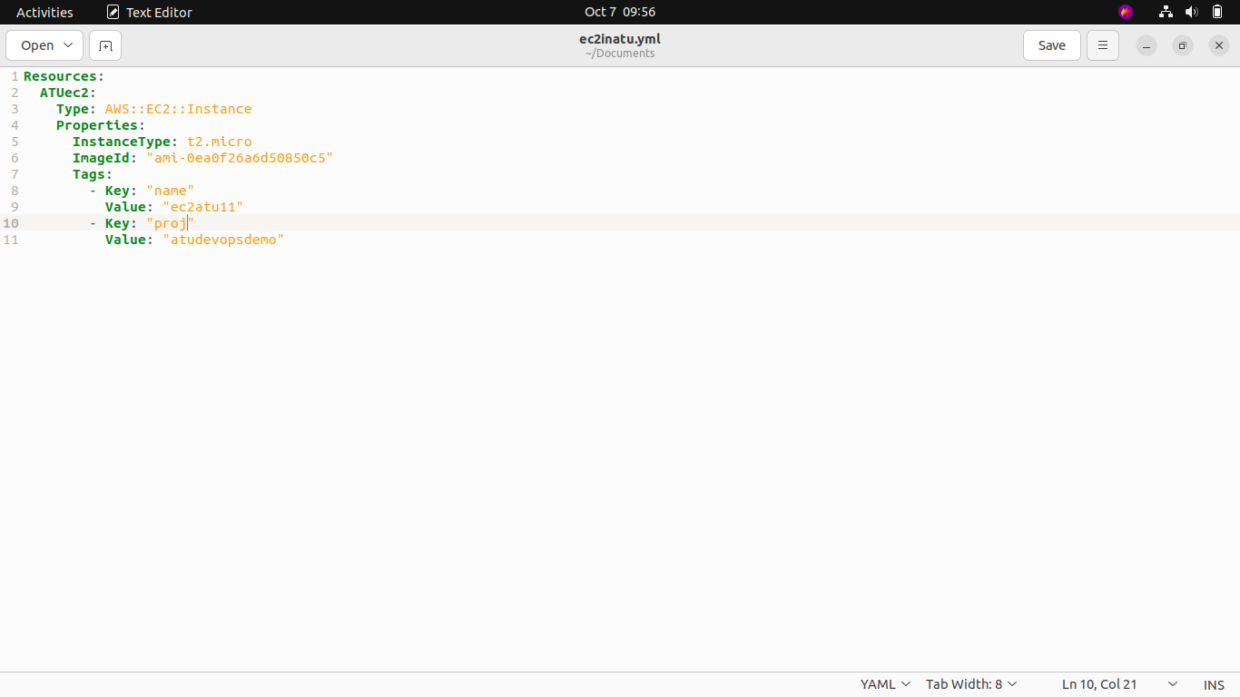2) Create a stack and upload your template.

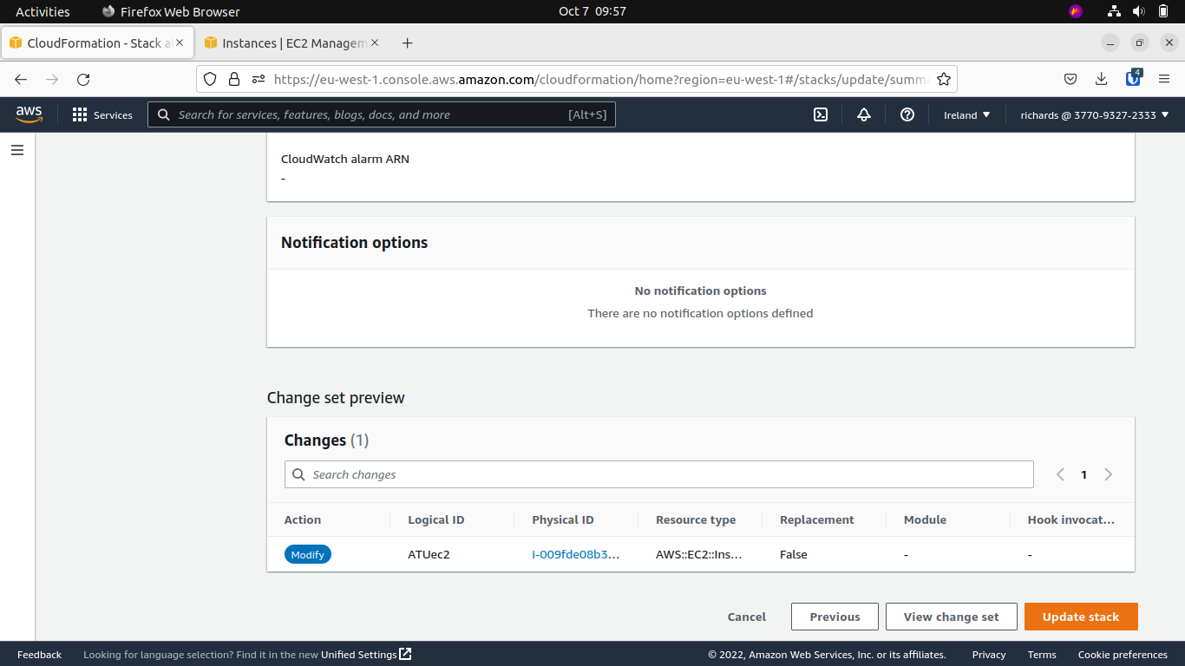

3) Finish creating the stack.

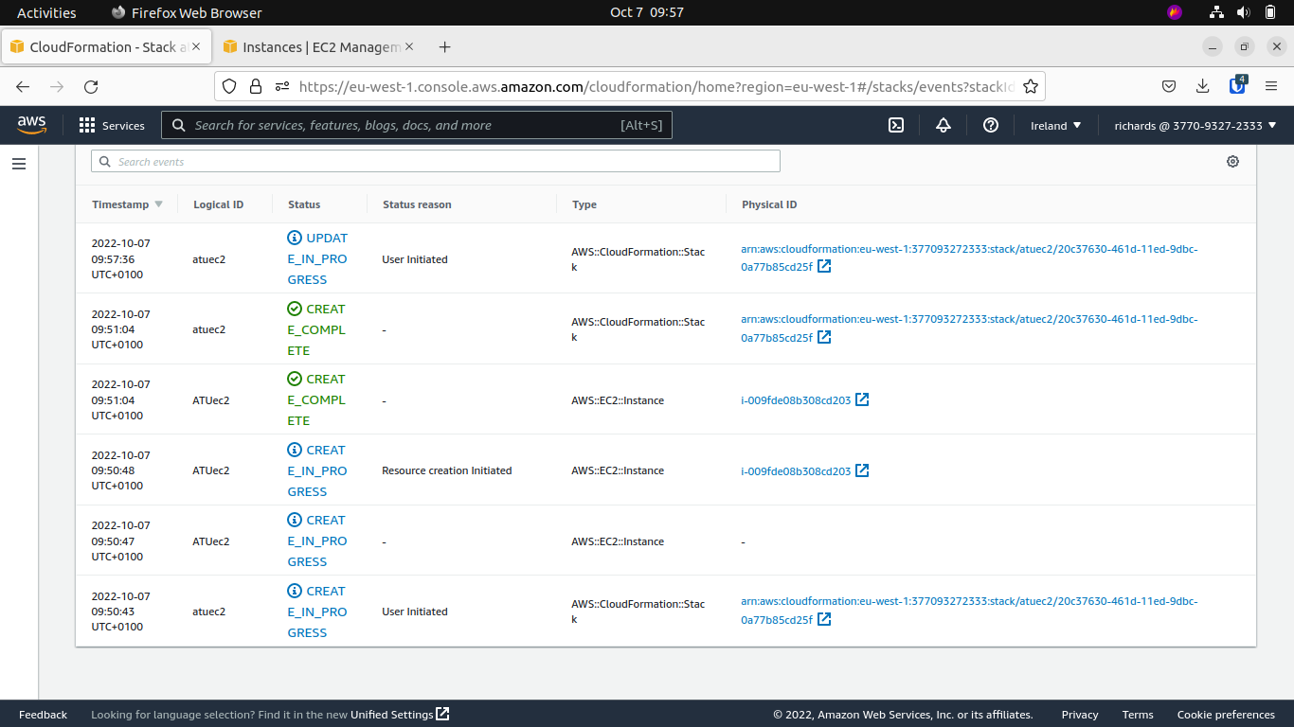4) It is possible to update the stack after creation by uploading another Cloud Formation template.

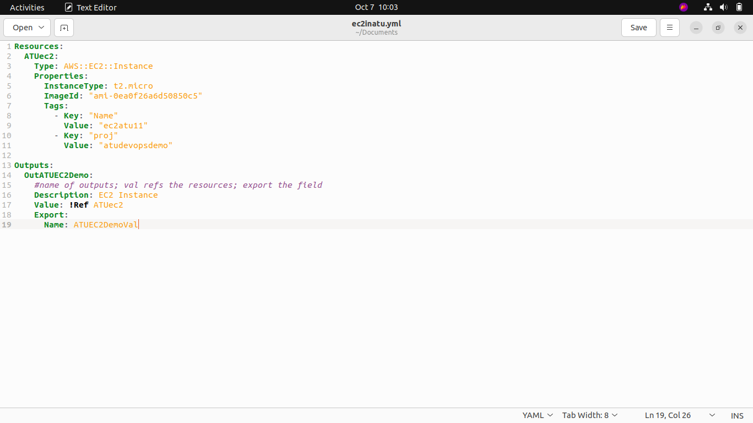

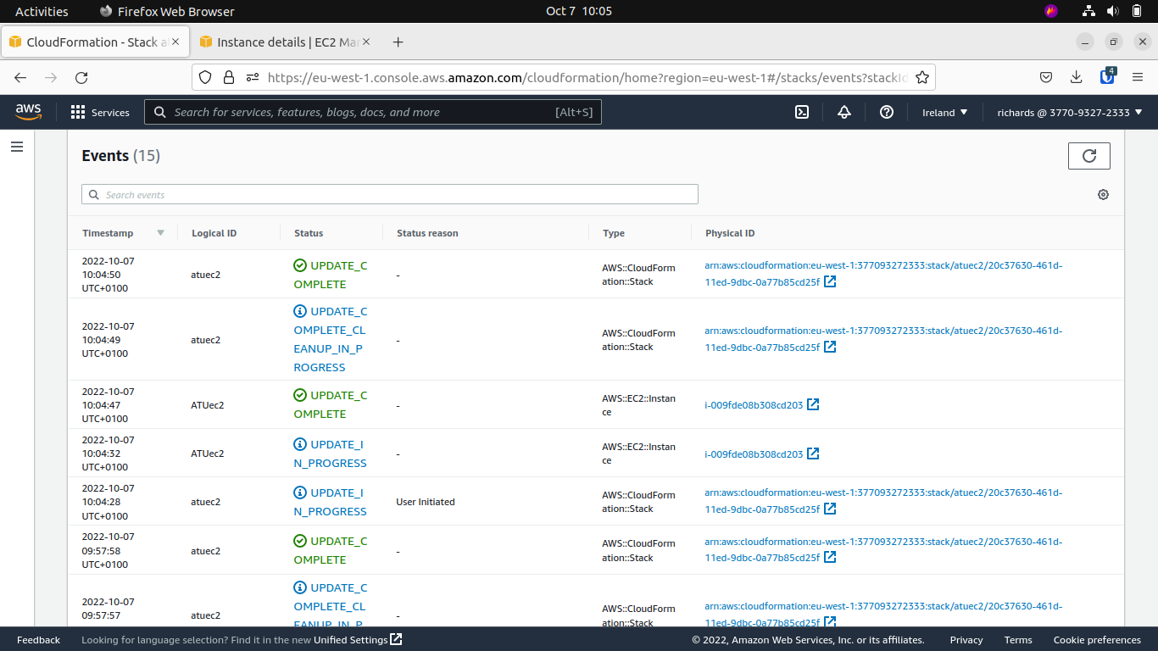5) Finish updating the stack.

**STEPS (S3):**

1. Get you pre-written template ready.

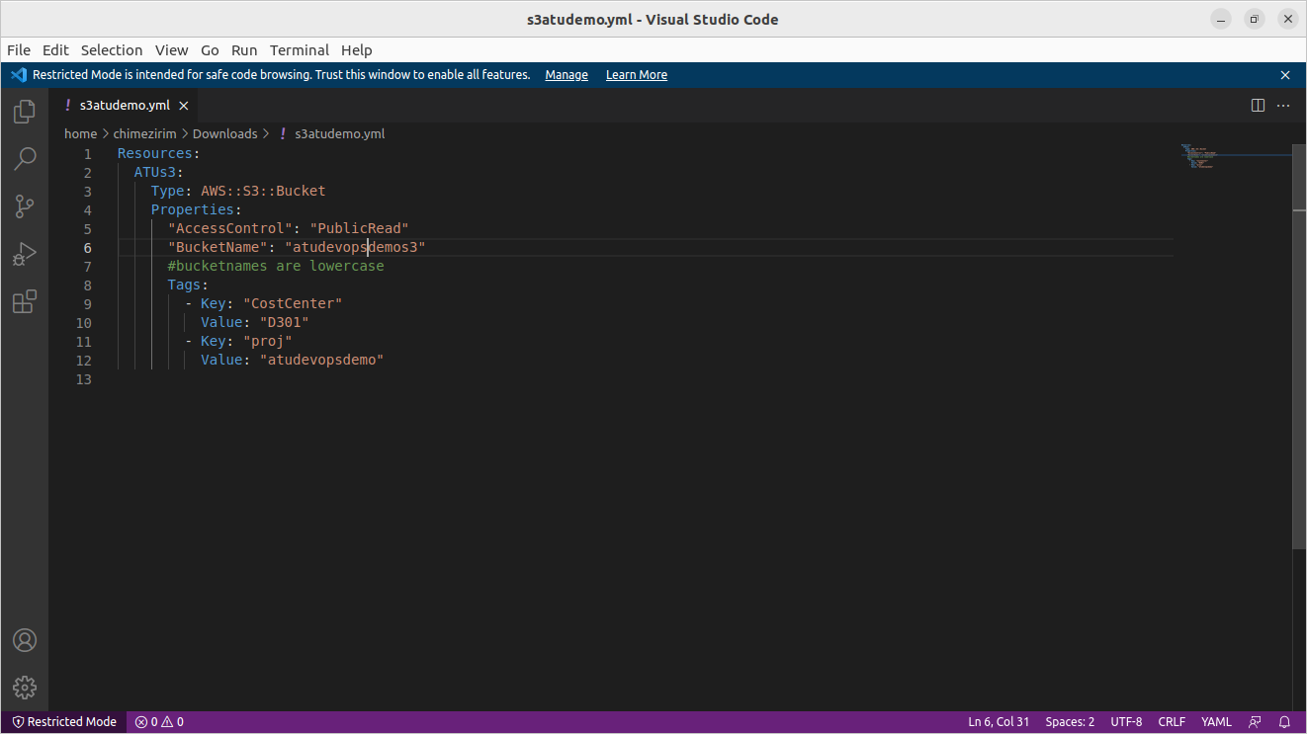

2) Create a stack and upload your template.

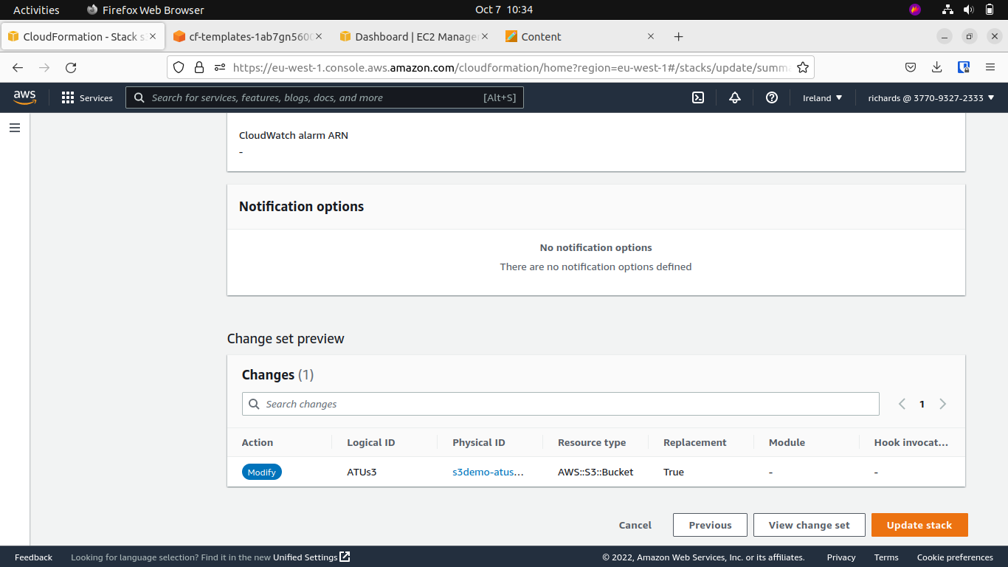

3) Finish creating the stack.

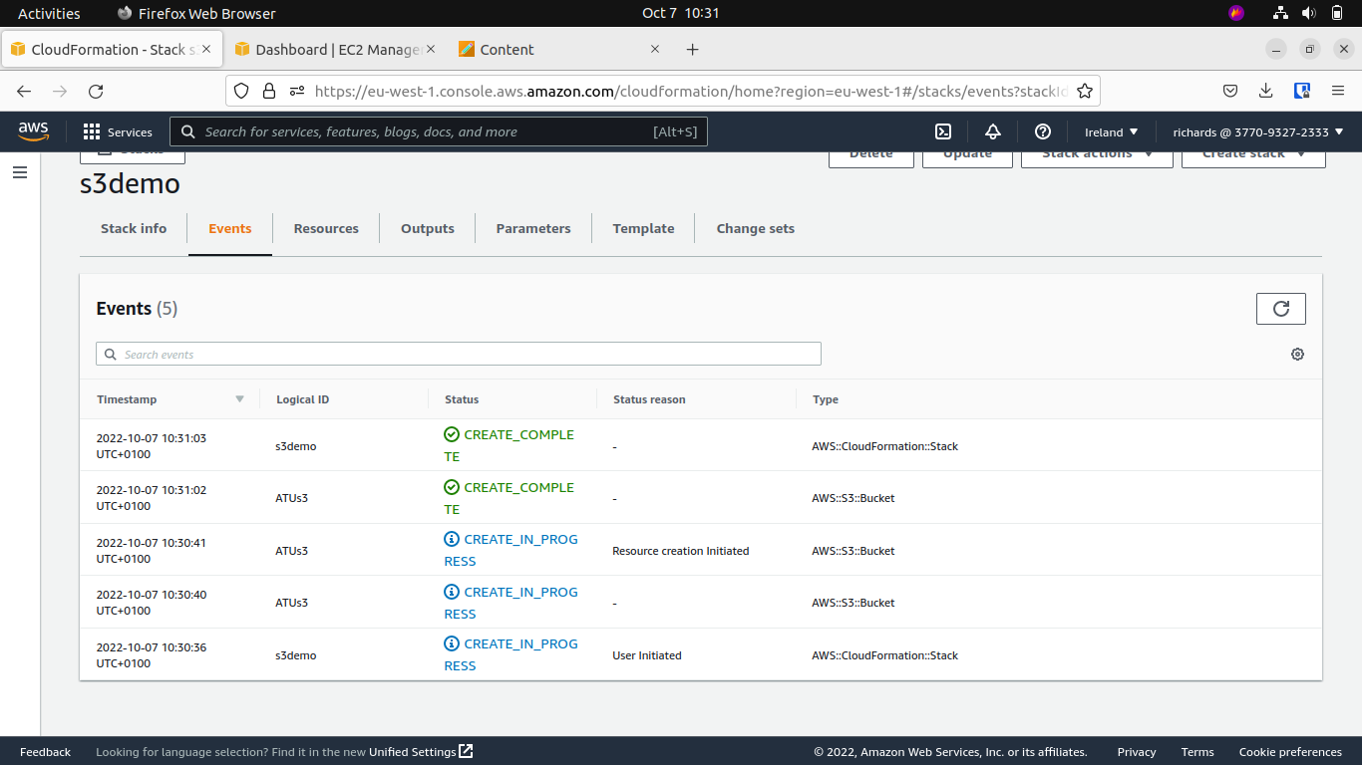

4) Check if the resources were created.

